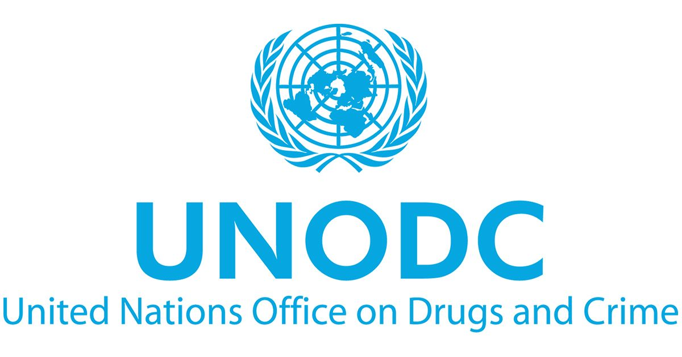
Committee: United Nations Office on Drugs and Crime

Presidents: Tristan Bohn, Gabriela Peña

Topic A:
East African Drug Trade and its Threat to International Security

Topic B:
Prisoner Rehabilitation Programs: What Works Best?

Index
Letter From The Chair

Introduction to the Committee
History of the Committee
Functions of the Committee

Topic A: East African Drug Trade and its Threat to International Security
Introduction
Historical Context
Current Situation
Guiding Questions

Topic B: Prisoner Rehabilitation Programs: What Works Best?
Introduction
Historical Context
Current Situation
Guiding Questions

Letter from the Chair
Dear delegates, we are Tristan Bohn and Gabriela Peña. As your two presidents, we are happy to welcome you to this incredible committee of UNODC. We are excited to be with you during this edition of CNGMUN, but we are especially excited to see the growth process that each of you will have within the three days of the model.

We hope that this will be a great experience, full of unforgettable memories and new learning based on the actions you will take during the three days of the model.

We have high expectations for what each of you can bring to the committee with your ideas and insights. Without further ado, your table is open to any questions or concerns you may have about the handbook, the process, your delegation, or anything else. Don't be afraid to ask! No question is silly, and that's why you've got us, we're both very willing to help you so that you can enjoy the committee and grow in it, so feel free to write to us by WhatsApp or email. We can't wait to see you on the 8th, 9th, and 10th of February, where we are sure we are going to have a great weekend with all of you. Together, we are going to make a great team!

Introduction to the Committee:

History:
The United Nations Office on Drugs and Crime (UNODC) was established in 1997 with the merging of the United Nations International Drug Control Program and the Crime Prevention and Criminal Justice Division in the United Nations Office at Vienna into a single office of the United Nations Secretariat, one of the 6 principal organs of the UN. The UNODC was established with 5 main goals in mind:
- Countering terrorism
- Tackling corruption
- Preventing crime and promoting criminal justice
- Combating organized crime
- Tackling the world drug problem

The UNODC has been tasked with the enforcement of a number of international multilateral treaties, including the United Nations Convention on Corruption in 2005 and the United Nations Convention against Transnational Organized Crime in 2003.

The UNODC has organized a number of campaigns to raise awareness on topics related to drugs and crime, notably “Do Drugs Control Your Life”, “Think AIDS”, and the Blue Heart Campaign, which opposes human trafficking.

Function and Powers:
The UNODC has two main programmes: the UN International Drug Control Programme and the Crime Prevention and Criminal Justice Program. The UNODC does the following through their programmes:
- Serves as the “central drug control entity” for the UN
- Acts to carry out the responsibilities of the Secretary-General of the UN
- Provides “substantive services” to the General Assembly and the Economic and Security Council of the UN
- Carries out activities with regard to drug control and international crime
- Promotes international and regional cooperation with regard to drug control and international crime

The head of the UNODC is the Executive Director. Under the Office of the Executive Director, there are 4 divisions that carry out the responsibilities of the UNODC:
- Division for Operations
- Division for Treaty Affairs
- Division for Policy Analysis and Public Affairs
- Division for Management

Work Cited
https://documents-dds-ny.un.org/doc/UNDOC/GEN/N04/272/92/PDF/N0427292.pdf?OpenElement
https://www.unodc.org/unodc/en/about-unodc/index.html

Topic A: East African Drug Trade and its Threat to International Security

Introduction:
With an estimated population of 260 million people in 2000, East Africa contains some of the most ethnically violent countries in Africa. Due to its location as a crossroads between the Indian Ocean, the Arabian peninsula, and the rest of Africa, there is a great deal of trade that occurs through the region. According to the UNODC, the trafficking of illicit drugs such as heroin, cocaine, cannabis, and ATS into and through East Africa has been growing in recent years.

Historical Context:
In the 1970s, due to worsening living standards, legal routes of commerce were beginning to be used for the transport of illicit drugs, primarily marijuana and heroin. In the 1980s and 1990s, cocaine from South America began to be transported to Europe through East Africa.
Many countries in the region have faced various internal conflicts over the years that have destabilized local and national governments, allowing illicit drugs to be more easily trafficked. Countries such as Kenya, Burundi, and Rwanda have experienced a multitude of ethnic conflicts, while Sudan and South Sudan have been devastated by civil wars and ethnic conflicts from the 1980s until today. Meanwhile, Ethiopia has been in a civil war since 2018. The most destructive of these civil wars is the Somali Civil War, which has seen the deaths of hundreds of thousands, the displacement of millions, and the collapse of the national government as well as local ones. These conflicts have been a driving force in the continued, rampant drug trafficking in the region.

Current Situation:
Currently, drug trafficking is a large problem for the region, and has been growing in recent years. The UNODC primarily attributes this growth to the following:
- East Africa and Africa in general have a growing demand for illicit drugs
- There is a large amount of international flights in the region
- “Inadequate trafficking controls” make it a relatively easy point of transport
- Corruption by law enforcement and customs officers
The effects of drug trafficking are extensive, and notably include increased corruption, an increase in rates of HIV, and a loss of productivity among young workers. Most importantly, many terrorist groups both within and without the region are linked to drug trafficking. Al-Shabaab, a Sunni extremist terrorist group part of Al-Qaeda that is the primary opponent of the Somali government in their civil war, for example, receives a lot of its funding through drug trafficking.
To counter these effects, the UNODC has ramped up their activities against drug trafficking in the last 20 years, although the problem still remains at large. The main obstacle in the path of the UNODC’s attempts are rampant corruption that plagues the region. Additionally, the civil wars in the area have left it unstable and consequently, vulnerable against large-scale drug trafficking.

Guiding Questions:
- How is your country affected by drug trafficking?
- What is your country’s stance on the regulation of drugs?
- Is your country currently fighting against any terrorist or extrajudicial groups? To what extent?
- What steps has your country taken to fight international drug trafficking?

Sources:
https://www.ncbi.nlm.nih.gov/pmc/articles/PMC4845648/
https://www.unodc.org/easternafrica/en/illicit-drugs/drug-trafficking-patterns.html
https://www.unodc.org/easternafrica/en/illicit-drugs1.html

Topic B: Prisoner Rehabilitation Programs: What Works Best?
Introduction:
Prisoner rehabilitation programs play a crucial role in addressing the societal challenges associated with incarceration. The effectiveness of these programs is a subject of ongoing debate and research. The development of this committee delves into the question: "Prisoner Rehabilitation Programs: What Works Best?" by examining various approaches and their impact on reducing recidivism rates, fostering skill development, and ultimately facilitating the successful reintegration of individuals into society.
By understanding the key principles and successful strategies, the proposals developed during the committee can contribute to a more informed and evidence-based approach to rehabilitation within the criminal justice system.
Adopted after the conclusion of the Thirteenth United Nations Congress on Crime Prevention and Criminal Justice, the Doha Declaration stressed the importance of taking measures to support the rehabilitation and social reintegration of prisoners into the community.
Within the framework of the Global Programme for the Implementation of the Doha Declaration and its pillar on fair, humane, and effective criminal justice systems, UNODC supported Member States in establishing a more rehabilitative approach to prison management.
Indeed, investments in corresponding programs for prisoners were identified as one of the best and most cost-effective ways to prevent recidivism, with significant benefits not only for the individuals concerned but also for public safety in general.

Historical Context
Prisoner rehabilitation programs have evolved over time in response to changing societal attitudes toward crime and the punishment to be meted out. The concept of providing an opportunity for rehabilitation to people who have committed crimes dates back to the eighteenth century and began to be implemented in the nineteenth and twentieth centuries. A brief account of what has been done in terms of rehabilitation programs and how it has evolved over the centuries is given below:

- 18th Century - Enlightenment Era:
The Enlightenment period marked a shift in thinking about criminal justice. Philosophers such as Cesare Beccaria and Jeremy Bentham advocated for more humane and rational approaches to punishment, with the idea that punishment should focus on reforming the offender rather than just inflicting pain. From these thoughts came the creation of programs for rehabilitation and reintegration into society by giving offenders a second chance, an idea that was criticized at the time because of society's doubts as to whether an individual who had committed a crime could change his or her ways.

- 19th century - Penitentiary movement:
The early 19th century saw the emergence of reform movements in the prison system. Figures such as Elizabeth Fry and Dorothea Dix advocated for more humane prison conditions and compassionate treatment of prisoners. In turn, penitentiaries were created, such as the Eastern State Penitentiary in Philadelphia (opened in 1829). These institutions sought to provide prisoners with an environment of reflection and repentance, emphasizing solitary confinement and religious introspection as a means of rehabilitation.

- Middle of the 20th Century:
During the mid-20th century, attention in the correctional field shifted toward the resocialization and social reintegration of prisoners. This period was marked by a shift in prison philosophy away from confinement and punishment toward the idea that inmates could benefit from programs designed to change their behavior and prepare them for life outside prison. This was through new programs for prisoners:
- Educational Programs: Providing inmates with opportunities to acquire skills and knowledge. These programs included basic education, vocational training and, in some cases, even higher education.
- Occupational Therapy: Provide inmates with productive and therapeutic activities. This included workshops, art activities and other forms of occupation that not only kept prisoners busy, but also sought to develop skills and foster a more positive mindset.
- Recreational Activities: The importance of recreational activities to the emotional well-being and mental health of inmates was recognized. The introduction of recreational facilities and sports programs sought not only to improve the physical condition of the prisoners, but also to provide a positive outlet for energy and reduce stress in the prison environment, so that when they came out of their time in prison the change would not be so drastic.
- Community Treatment Correctional Model: The community treatment model was developed, which emphasized the importance of connecting inmates to the community to facilitate successful rehabilitation. This involved a gradual transition from prison to more open settings, such as halfway houses or parole programs, where inmates could receive ongoing support as they reintegrated into society.

Current Situation
“Rehabilitation includes a number of venues, but for UNODC's Prisoner Rehabilitation initiative, resources and support have been developed in the three core areas of education, vocational training, and employment during prison years, with the goal of contributing to the prisoners' employability after release, and thus reducing chances of recidivism.” (UNODC)
- Modern and Alternative Approaches
  - Restorative Justice: Restorative justice is an approach that emphasizes repairing the harm caused by crime and reconciliation between the offender, the victim, and the community. It focuses on involving all affected parties in a problem-solving process, to restore harmony and prevent recidivism.
  - Victim-Offender Mediation: Mediation programs facilitate direct dialogue between victims and offenders, allowing them to understand the consequences of their actions. This approach promotes personal responsibility and can generate agreements that go beyond traditional sanctions.
  - Technology and Distance Education: Technology has facilitated the implementation of rehabilitation programs through distance education. Inmates can access online courses, educational programs, and job training, allowing them to acquire skills and knowledge relevant to their reintegration into society.
- Focus on Mental Health and Substance Abuse
  - Treatment Services in Jails and Prisons: Recognizing the importance of addressing underlying issues, many correctional facilities have implemented specific treatment and counseling services to address mental health and substance abuse. This includes rehabilitation programs that focus on cognitive-behavioral therapies and detoxification programs.
  - Specialized Programs: Specialized programs have been established within correctional facilities to address the specific needs of inmates with mental health or addiction issues. These programs seek to provide a more personalized and effective approach to rehabilitation.
- Collaboration with Communities and External Organizations
  - Transition to Society Support: Collaboration between correctional institutions and community organizations is essential to provide a strong support system as inmates transition back into society. This involves employment, housing, and counseling programs that extend beyond the prison walls.
- Continuous Evaluation and Data-Based Approach
  - Effectiveness Monitoring: Ongoing evaluation of rehabilitation programs is essential to measure their effectiveness. This involves constant monitoring of recidivism rates, impact on inmates' lives, and effectiveness in reducing criminal risk.
  - Evidence-Based Approaches: Evidence-based programs seek to identify and apply strategies that are effective in reducing recidivism. Data collection and analysis play a crucial role in determining best practices and making informed decisions to improve rehabilitation outcomes.

Guiding Questions
- What rehabilitation programs has your city implemented?
- What is the effectiveness rate of these rehabilitation programs?
- How does your city feel about giving inmates a second chance?
- Do the prison systems in your country meet sanitation requirements and treat prisoners with dignity?
- Do the prison systems in your country contribute to the functionality of rehabilitation systems?
- What is the public opinion in your country about rehabilitation programs?

Sources:
https://www.encyclopedia.com/reference/encyclopedias-almanacs-transcripts-and-maps/history-corrections-punishment-prevention-or-rehabilitation
https://www.unodc.org/dohadeclaration/en/prisons/index.html#:~:text=Rehabilitation%20includes%20a%20number%20of,employability%20after%20release%2C%20and%20thus
https://www.unodc.org/dohadeclaration/topics/prisoner-rehabilitation.html
https://www.unodc.org/documents/dohadeclaration/Prisons/infosheet/info_sheet_Prisons_EN.pdf

